**MINI PROJECT REPORT**

**TIC-TAC-TOE**



REPORT SUBMITTED

TO

VISHWAKARMA INSTITUTE OF INFORMATION TECHNOLOGY, PUNE

IN

**INFORMATION TECHNOLOGY DEPARTMENT**

Prepared by :

|  |  |  |
| --- | --- | --- |
| **Name** | **Roll No.** | **GR No.** |
| Sanket Deshmane | 332012 | 21810492 |
| Surya Ruikar | 332055 | 21810087 |
| Omkar Raje | 332047 | 21810859 |
| Siddharth Kothari | 332031 | 21810737 |

**Submitted to**: Dr. Pravin Futane

**Acknowledgement**

The satisfaction that accompanies the successful completion of this project would be incomplete without the mention of the people who made it possible, without whose constant guidance and encouragement would have made efforts go in vain. I consider myself and my team to express gratitude and respect towards all those who guided us through the completion of this project.

I and my team, convey thanks to my project guide **Dr. Pravin Futane** sir of Information Technology Department for providing encouragement, constant support and guidance which was a great help to complete this project successfully.

We also wish to thank our **parents**, for constantly encouraging us to learn engineering.

**Abstract**

In this Artificial Intelligence project we are developing TIC TAC TOE game.This is basic AI project in which we are using MINIMAX ALGORITHM and ALPHA BETA PRUNING using HTML, CSS and JavaScript.

In this project Minimax algorithm plays major role . Mini-max algorithm is a recursive or backtracking algorithm which is used in decision-making and game theory. It provides an optimal move for the player assuming that opponent is also playing optimally. Mini-Max algorithm uses recursion to search through the game-tree. Min-Max algorithm is mostly used for game playing in AI. Such as Chess, Checkers, tic-tac-toe, go, and various tow-players game. This Algorithm computes the minimax decision for the current state. In this algorithm two players play the game, one is called MAX and other is called MIN. Both the players fight it as the opponent player gets the minimum benefit while they get the maximum benefit. Both Players of the game are opponent of each other, where MAX will select the maximized value and MIN will select the minimized value. The minimax algorithm performs a depth-first search algorithm for the exploration of the complete game tree.

In order to win the game, a player must place three of their marks in a

horizontal, vertical, or diagonal row

**INDEX**

* 1. Introduction……………………………………………………5
* Purpose.
* System Overview.
* Problem Statement.
* Goals and Vision.
  1. Literature Survey……………………………………………….7
  2. Proposed Methodology…………………………………………8
* Rules of the Game.
* Algorithms.
* Flowchart
  1. Coding…………………………………………………………11
  2. Testing………………………………………………………...13
  3. Summary………………………………………………………15
  4. References……………………………………………………..16

**Introduction.**

As name suggest we are developing TIC-TAC-TOE game. This is basic AI project in which we are using HTML, CSS, JavaSCRIPT and basic concepts of Artificial Intelligence

* **Purpose.**

In this project, we are using AI in Game Development module in which we have implemented some basic concepts of AI like Mini-Max algorithm and Alpha-Beta Pruning Algorithm. A lot of AI in game development goes toward defining the way a computer opponent behaves. Behavior can range from relatively simple patterns in action games all the way to chess programs that can beat champion human players.

* **System Overview**.

In this project Minimax algorithm plays major role . Mini-max algorithm is a recursive or backtracking algorithm which is used in decision-making and game theory. It provides an optimal move for the player assuming that opponent is also playing optimally. Mini-Max algorithm uses recursion to search through the game-tree. Min-Max algorithm is mostly used for game playing in AI. Such as Chess,

Checkers, tic-tac-toe, go, and various tow-players game. This Algorithm computes the minimax decision for the current state. In this algorithm two players play the game, one is called MAX and other is called MIN. Both the players fight it as the opponent player gets the minimum benefit while they get the maximum benefit. Both Players of the game are opponent of each other, where MAX will select the maximized value and MIN will select the minimized value. The minimax algorithm performs a depth-first search algorithm for the exploration of the complete game tree.

In order to win the game, a player must place three of their marks in a horizontal, vertical, or diagonal row.

.

* **Problem Statement.**

Artificial Intelligence in Game Development.

Make TIC-TAC-TOE game by implementing Mini-Max Algorithm and Web languages.

* **Goals and Vision.**

To make Complete TIC-TAC-TOE Game using Alpha-Beta Pruning (search algorithms) so that anyone can play this game with computer.

**Literature Survey**

* **COMPARISION BETWEEN MINI-MAX AND ALPHA-BETA PRUNING**

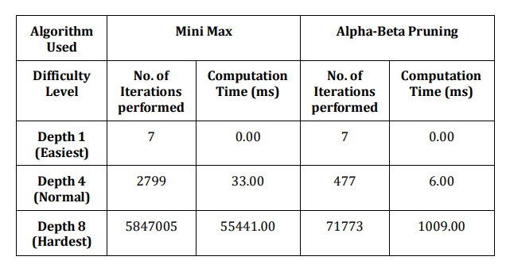

* **CONCLUSION :**

The study revealed that for the same level of difficulty the two algorithms behave very differently in terms of number of iterations performed and time taken with alpha beta pruning taking much less time and performing very few iterations than mini-max to generate the game state

**Proposed Methodology.**

**Rules of the Game.**

* The game is to be played between two people (in this program between HUMAN and COMPUTER).
* One of the player chooses between stone paper scissor and other player also has to chooses between stone paper scissor
* When game start both player choose anyone option simultaneously
* A player who decides to play rock will beat another player who has chosen scissors ("rock crushes scissors" or sometimes "blunts scissors"), but will lose to one who has played paper ("paper covers rock"); a play of paper will lose to a play of scissors ("scissors cuts paper").
* If no one wins, then the game is said to be draw.

**Algorithms.**

Minimax Algorithm :

Minimax is a kind of backtracking algorithm that is used in decision making and game theory to find the optimal move for a player, assuming that your opponent also plays optimally.

In Minimax the two players are called maximizer and minimizer. The maximizer tries to get the highest score possible while the minimizer tries to do the opposite and get the lowest score possible.

Every board state has a value associated with it. In a given state if the maximizer has upper hand then, the score of the board will tend to be some positive value. If the minimizer has the upper hand in that board state then it will tend to be some negative value. The values of the board are calculated by some heuristics which are unique for every type of game

.

Alpha Beta Pruning :

Alpha-Beta pruning is not actually a new algorithm, rather an optimization technique for minimax algorithm. It reduces the computation time by a huge factor. This allows us to search much faster and even go into deeper levels in the game tree. It cuts off branches in the game tree which need not be searched because there already exists a better move available. It is called Alpha-Beta pruning because it passes 2 extra parameters in the minimax function, namely alpha and beta.

The dotted lines represent the lines that were pruned

**Flowchart**

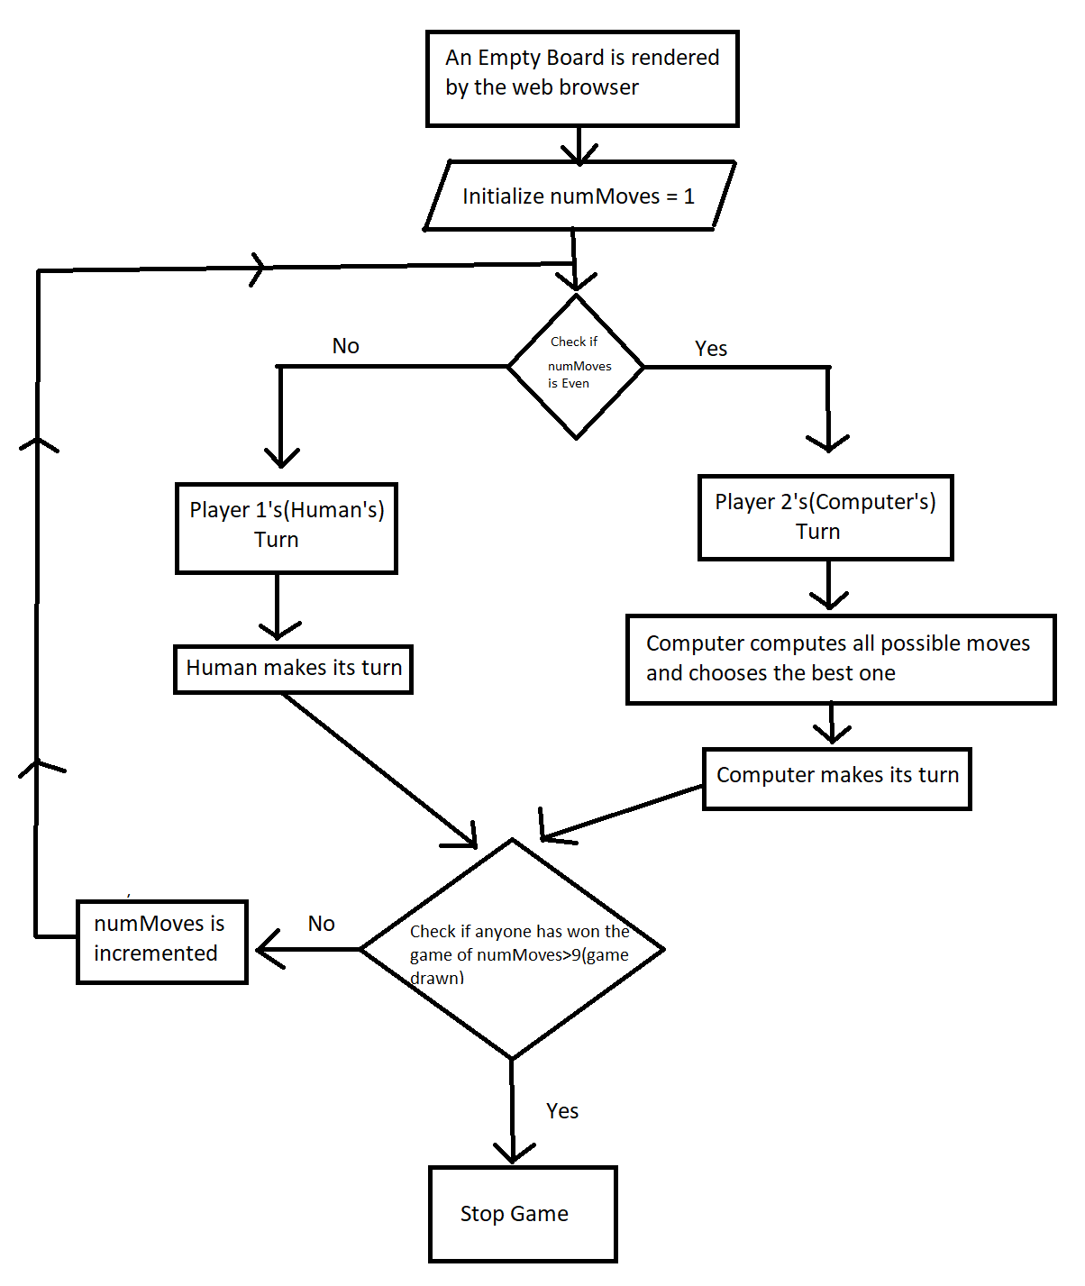

**Coding**

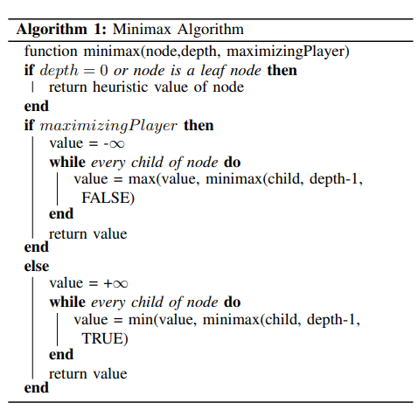

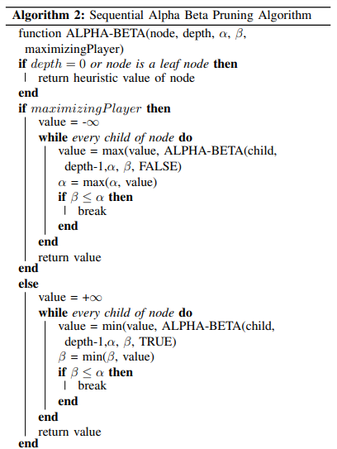

**Testing**

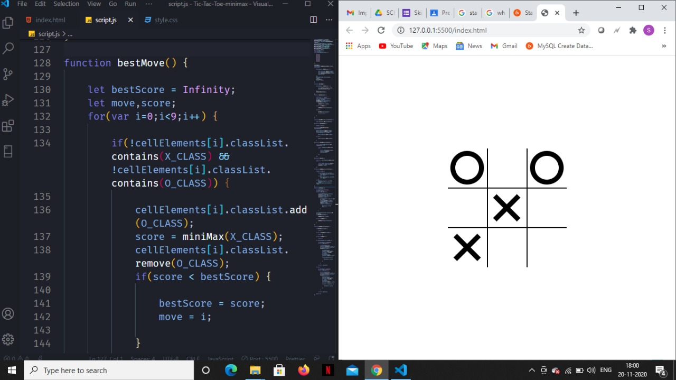

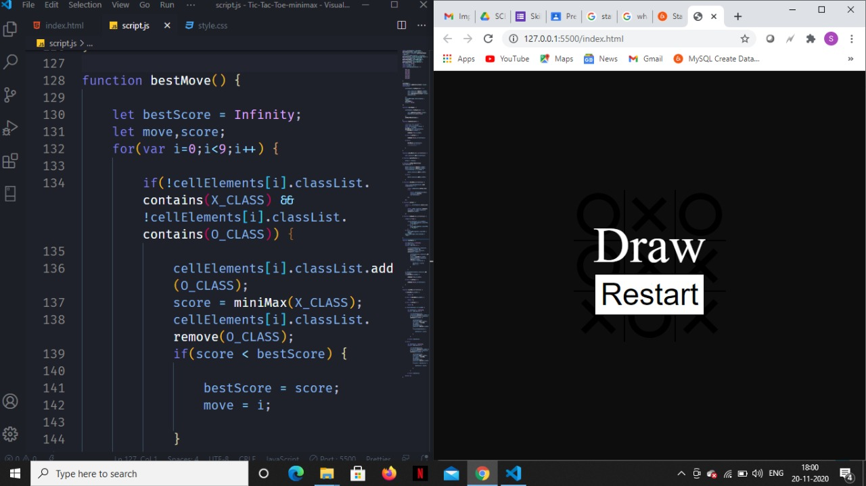

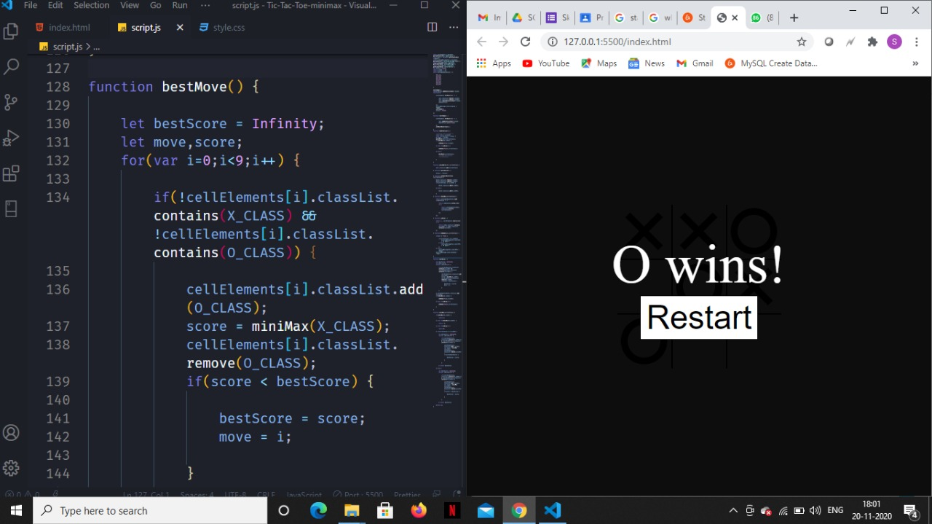

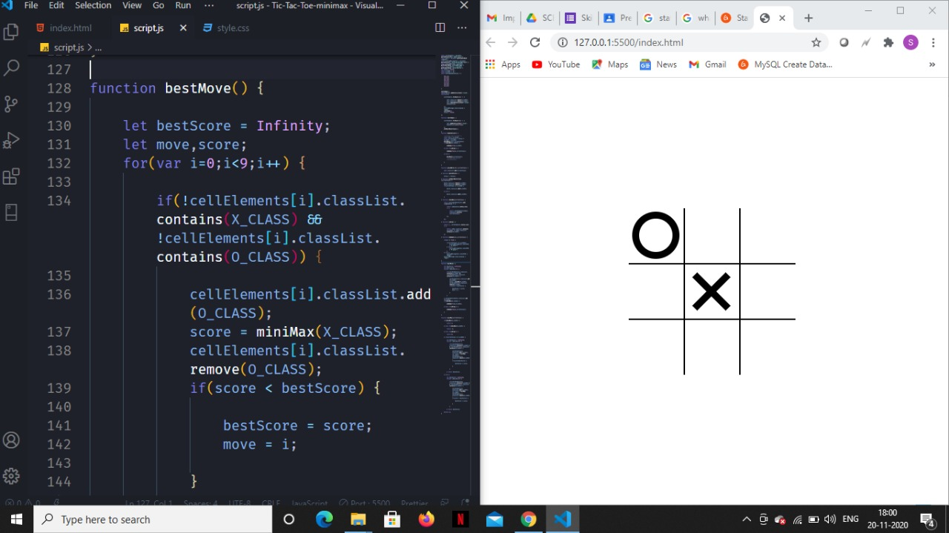

**Summary**

Over the next five years, we are about to witness the world we live in entirely disrupted by improvements in artificial intelligence (AI) and machine learning. Children today are growing up with AI assistants in their homes (Google Assistant, Siri and Alexa) -- to the point that you might consider their mere presence an extension of co-parenting. As voice and facial recognition continue to evolve, machine learning algorithms are getting smarter. More and more industries are being influenced by AI, and our society as we know it is transforming.

So, we can use AI everywhere .

**References**

* **Research Papers for Image Processing :**

1)Comparative study of performance of parallel Alpha Beta Pruning for different architectures by Shubhendra Pal Singhal and M. Sridevi

2)Alpha-Beta Pruning in Mini-Max Algorithm –An Optimized Approach for a Connect-4 Game Rijul Nasa1, Rishabh Didwania2, Shubhranil Maji3, Vipul Kumar4 1,2,3,4 Dept. of Computer Science & Engineering, The National Institute of Engineering, Mysuru, Karnataka, India

* **Youtube**

https://youtu.be/dEs_kbvu_0s

* **Geeksfogeeks**

<https://www.geeksforgeeks.org/artificial-intelligence-an-introduction/>